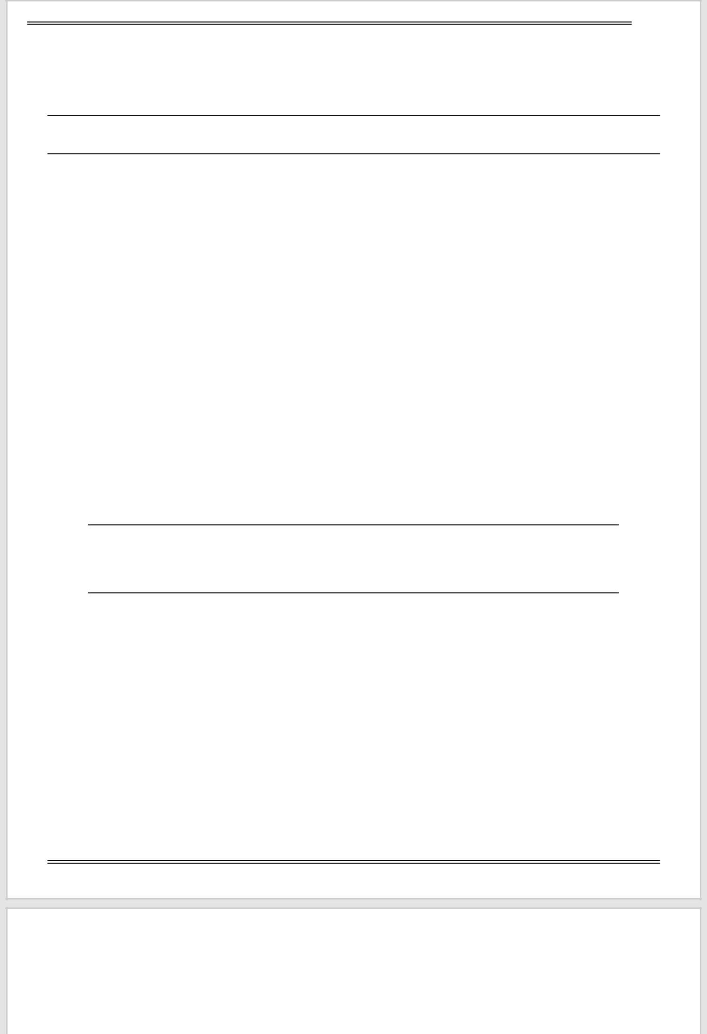
UNITED STATES

SECURITIES AND EXCHANGE COMMISSION

WASHINGTON, DC 20549

SCHEDULE 14A

Proxy Statement Pursuant to Section 14(a)

of the Securities Exchange Act of 1934

(Amendment No. )

Filed by the Registrant ☒

Filed by a party other than the Registrant ☐

Check the appropriate box:

- Preliminary Proxy Statement

- Confidential, for Use of the Commission Only (as permitted by Rule 14a-6(e)(2))

- Definitive Proxy Statement

- Definitive Additional Materials

- Soliciting Material under §240.14a-12

PERELLA WEINBERG PARTNERS

(Exact Name of Registrant as Specified in its Charter)

Payment of Filing Fee (Check all boxes that apply):

- No fee required

- Fee paid previously with preliminary materials

- Fee computed on table in exhibit required by Item 25(b) per Exchange Act Rules 14a-6(i)(1) and 0-11



